A Gharda Chemicals Ltd. initiative
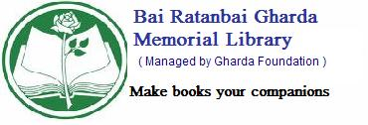
BAI RATAN BAI GHARDA MEMORIAL LIBRARY
(Managed by Gharda Foundation)
Gharda House, 48, Hill Road, Bandra (W), Mumbai – 400 050.
Tel:022-26419309.

BOOK A BOOK
Dear Librarian,

Kindly book, the following book, for me.

I am aware that after receipt of SMS on my mobile or telephonic communication, if I fail to collect the book within 3 days, I will automatically lose my claim.

I also agree to pay Rs.20/- towards booking charges while collecting the book.

My membership details are as follows:

Name:……………………………………………………………

Membership No.: Category: Mobile:

Signature of the member

